In above algorithm, we found more complexity on algorithm 1 in comparison algorithm 2. But while using Big0 notation, if we remove constant, we found complexity 0(n).

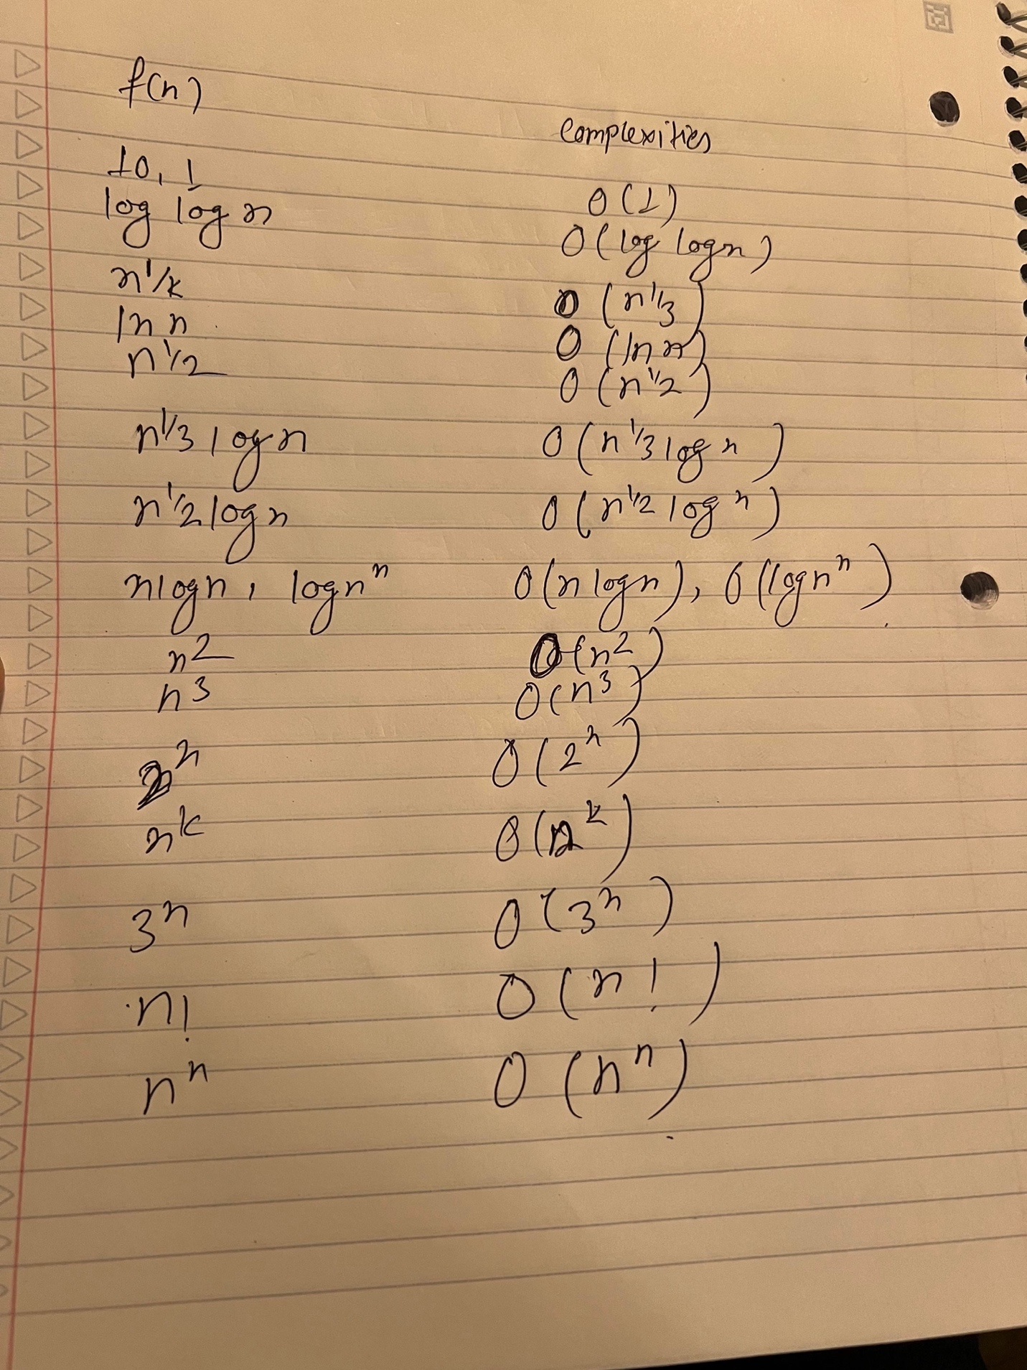

Best Regards,

Binod Pant(614654)

Jenish Ghimire(614700)

Sanjaya Koju (614759)